# **SYS 6018 Quiz 11.1**

## **H. Diana McSpadden (hdm5s)**

4/24/2021

## **Circle Dataset**

Test loss 0.160

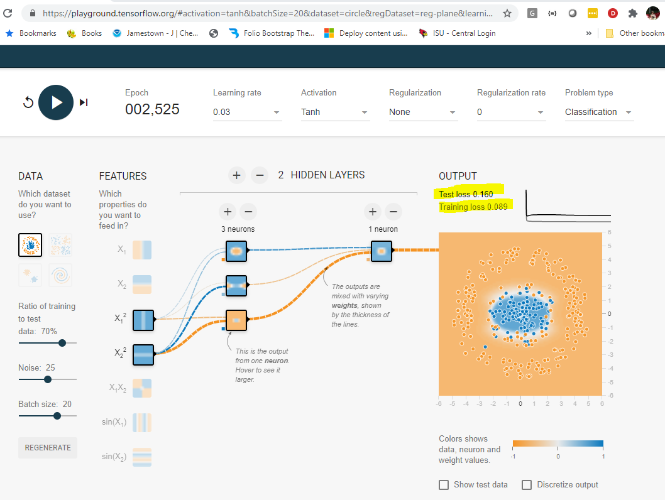

## **Exclusive Or Dataset**

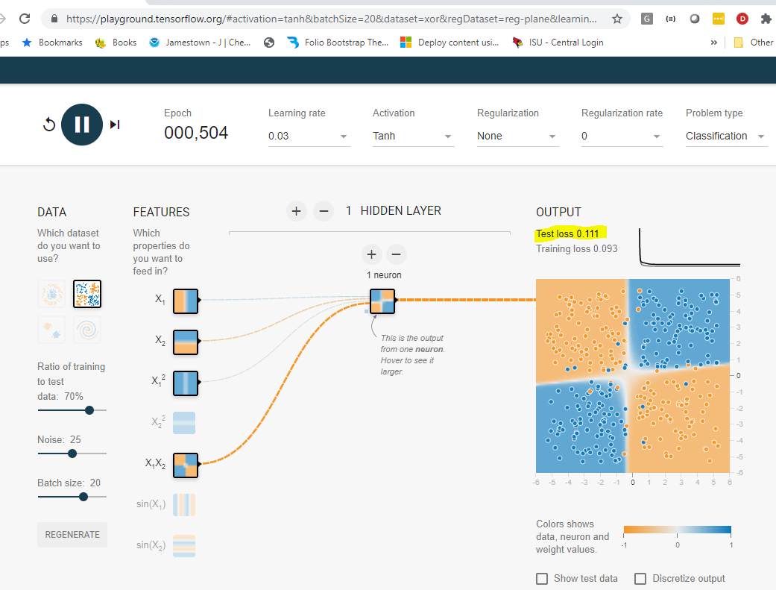

## **Gaussian Dataset**

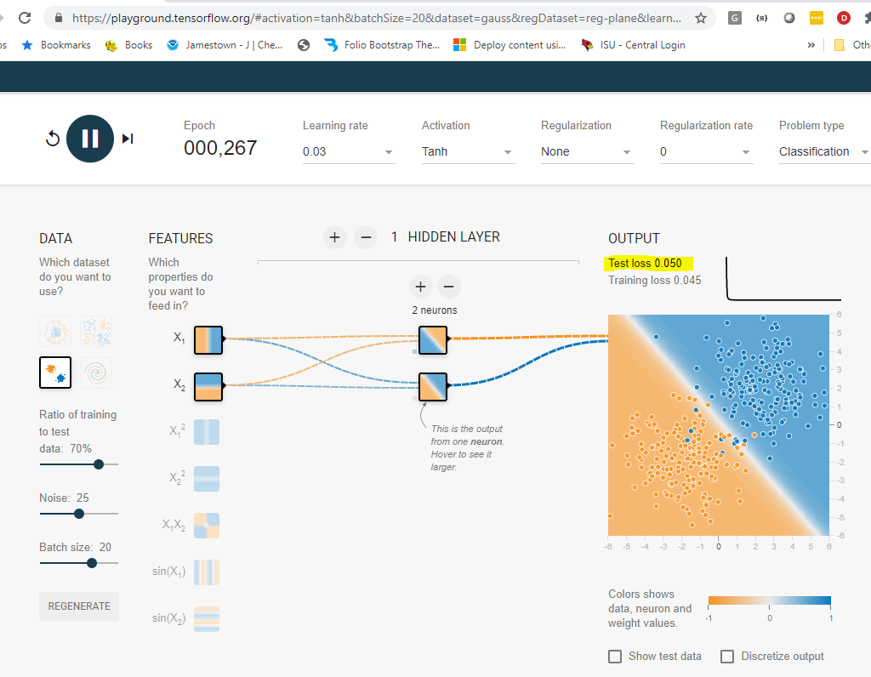

## **Spiral Dataset**

